* **Exercise 2: E-commerce Platform Search Function**

Output :

* Using Linear Search :

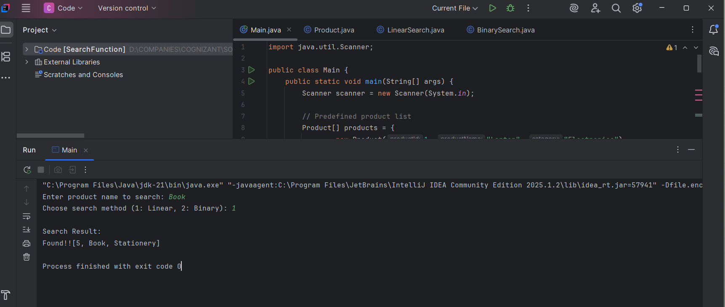

* Using Binary Search :

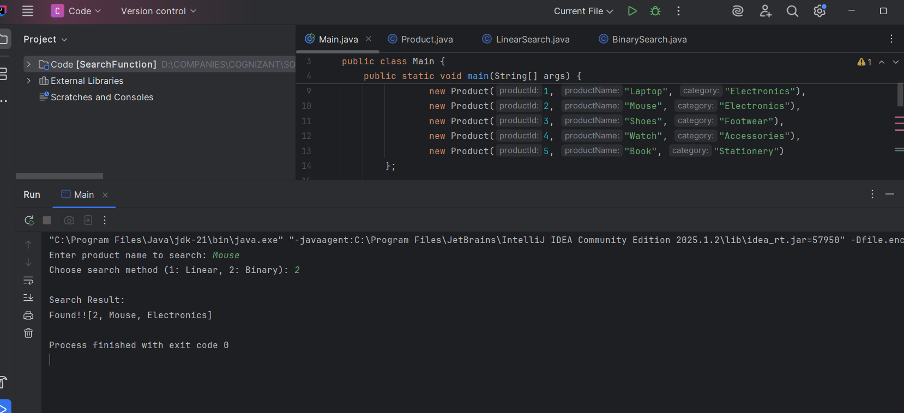

* If Product is not Available:

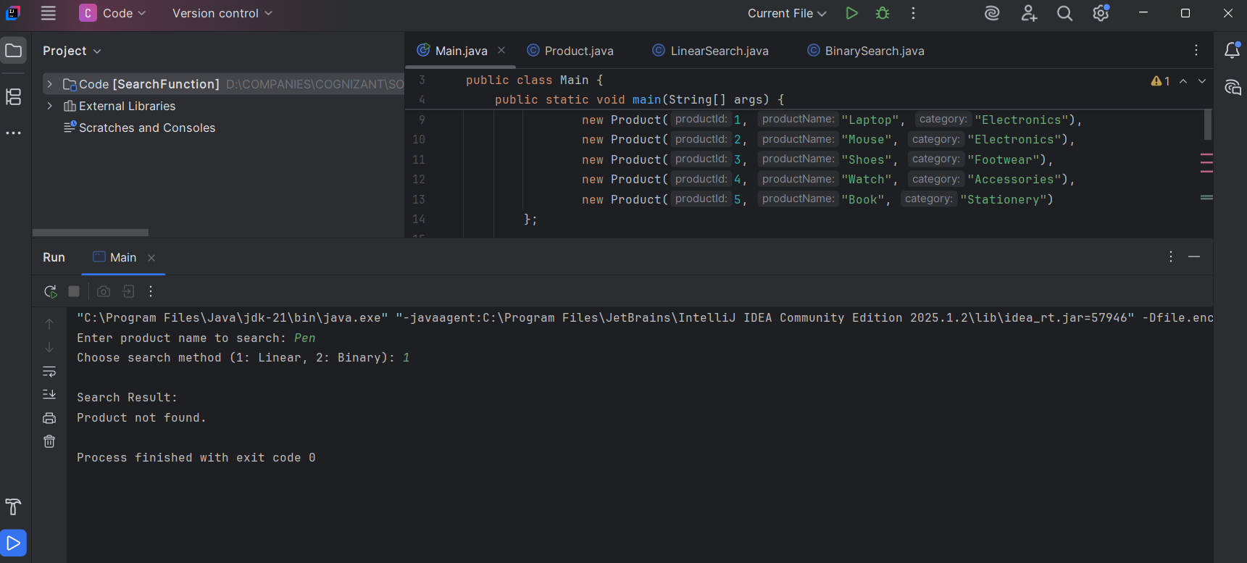

* Comparing Linear Search and Binary Search :

|  |  |  |
| --- | --- | --- |
| **Feature** | **Linear Search** | **Binary Search** |
| **Data Requirement** | Works on unsorted or sorted data | Requires sorted data |
| **Time Complexity (Best)** | O(1) | O(1) |
| **Time Complexity (Average)** | O(n) | O(log n) |
| **Time Complexity (Worst)** | O(n) | O(log n) |
| **Space Complexity** | O(1) | O(1) (iterative), O(log n) (recursive) |
| **Method Type** | Sequential | Divide and conquer |
| **Suitable For** | Small or unsorted datasets | Large and sorted datasets |
| **Implementation Ease** | Very simple | Moderate complexity |